SPRINT-3

|  |  |
| --- | --- |
| PROJECT TILE | Project – Nutrition Assistant Application |
| TEAM ID | PNT2022TMID08258 |

Upload photo:

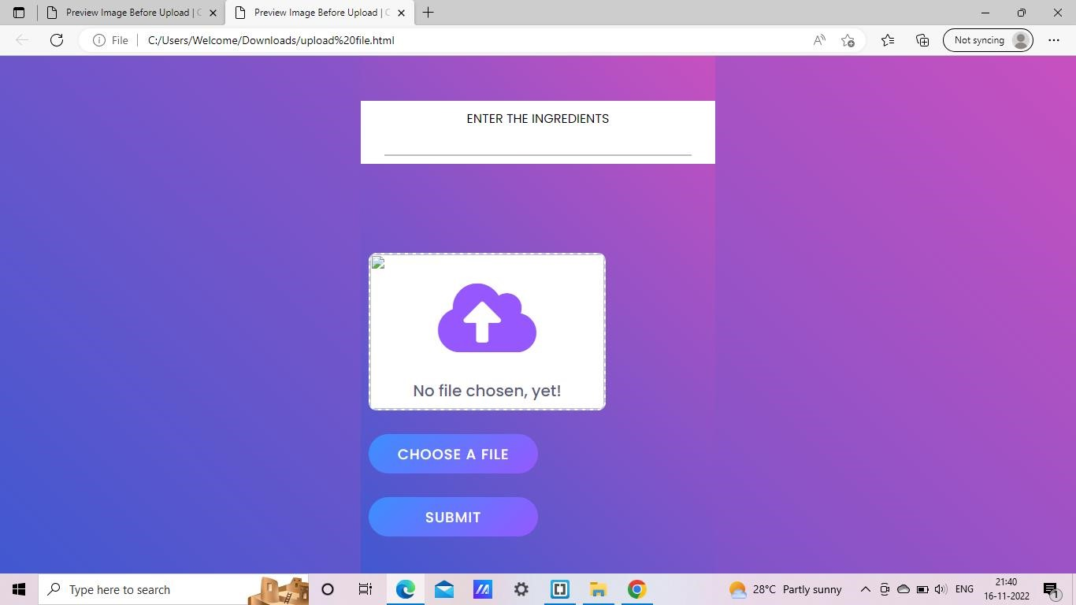

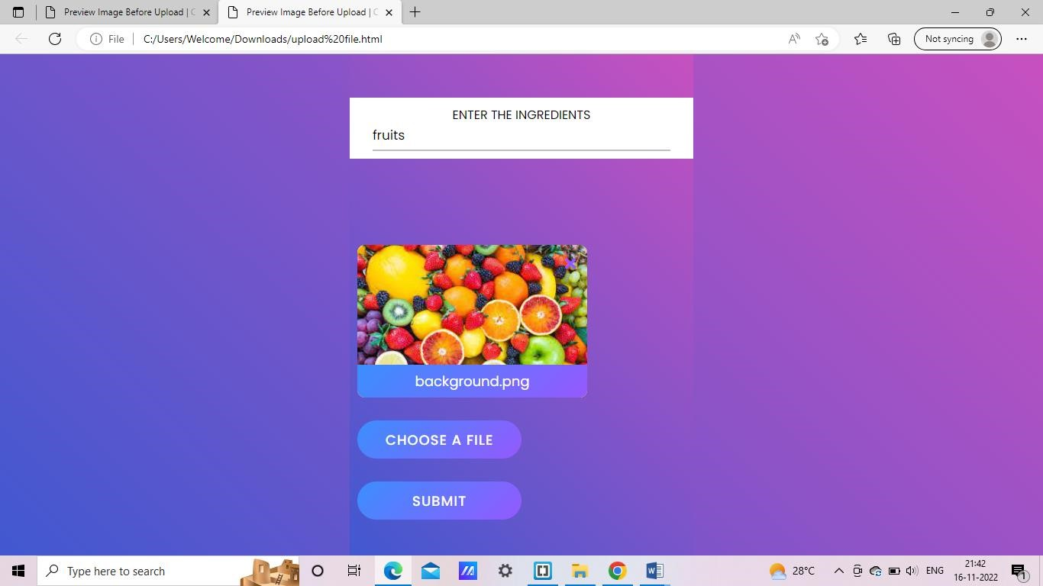

MAIN PAGE:

